TASK 1

import java.io.\***;**import java.util.ArrayList**;**public class Main {  
 public static void main(String[] args) throws IOException {  
  
 ArrayList<String> list = new ArrayList<>()**;** FileWriter fileWriter = null**;** File f1 = new File("Lab 11.txt")**;** try {  
 if (f1.createNewFile()) System.*out*.println("File created successfully")**;** }catch (IOException e){  
 e.printStackTrace()**;** }  
 list.add("Partham")**;** list.add("Kumar")**;** list.add("22k-4079")**;** list.add("BS AI 2b")**;** try {  
 fileWriter = new FileWriter("Lab 11.txt")**;** fileWriter.write(String.*valueOf*(list))**;** System.*out*.println("Write")**;** fileWriter.close()**;** }catch (IOException e){  
 e.printStackTrace()**;** }  
 BufferedReader br = new BufferedReader(new FileReader("Lab 11.txt"))**;** String buffer**;** while ((buffer = br.readLine())!=null){  
 System.*out*.println(buffer)**;** }  
 br.close()**;** Boolean delete = f1.delete()**;** if (delete){  
 System.*out*.println("Deleted")**;** }else System.*out*.println("Not deleted")**;** }  
}

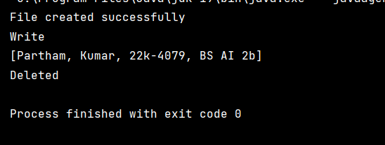

TASK 2

import javax.imageio.IIOException**;**import java.io.\***;**import java.util.ArrayList**;**import java.util.Scanner**;**public class Main {  
 public static void main(String[] args) throws IOException {  
 Scanner get = new Scanner(System.*in*)**;** System.*out*.println("Hello world!")**;** ArrayList<String> course = new ArrayList<>()**;** File f1 = new File("Partham kumar .txt")**;** try {  
 if (f1.createNewFile())  
 System.*out*.println("created")**;** }catch (IOException e){  
 e.printStackTrace()**;** }  
  
 System.*out*.println("IS PF Lab's Score above 50")**;** System.*out*.println("IS PF Score above 50")**;** boolean Pflab = get.hasNext()**;** boolean pf= get.hasNext()**;** if (pf==true && Pflab==true){  
 System.*out*.println("You can register for oop lab and oop")**;** }else System.*out*.println("You can not register for oop")**;** course.add("oop")**;** course.add("DLD")**;** course.add("DE")**;** course.add("Ethics")**;** course.add("La")**;** course.add("DS")**;** if (course.size()>**5**){  
 System.*out*.println("Be Careful while adding the course")**;** }  
  
 FileWriter writer = new FileWriter("Partham kumar .txt")**;** writer.write("Partham kumar")**;** writer.write("22k-4079")**;** writer.write(String.*valueOf*(course))**;** System.*out*.println("Written")**;** writer.close()**;** BufferedReader br = new BufferedReader(new FileReader("Partham kumar .txt"))**;** String buffer**;** while ((buffer = br.readLine())!=null){  
 System.*out*.println(buffer)**;** }  
 br.close()**;** }  
}

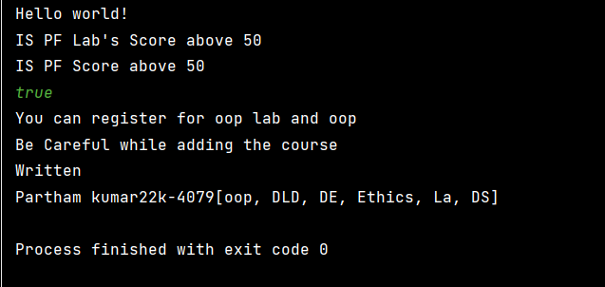

TASK 3

class use{  
 public static <**T** extends Comparable<**T**>> **T** findMax(**T**[] arr) {  
 **T** max = arr[**0**]**;** for (int i = **1;** i < arr.length**;** i++) {  
 if (arr[i].compareTo(max) > **0**) {  
 max = arr[i]**;** }  
 }  
 return max**;** }  
}  
public class Main {  
 public static void main(String[] args) {  
 use u1 = new use()**;** //int[] array={1,2,3,4,5,6,7,8,9};  
 String[] stg={"Partham kumar"}**;** System.*out*.println(use.*findMax*(stg))**;** }  
}

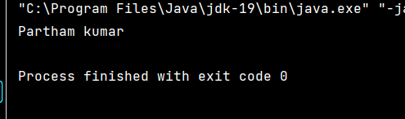

TASK 4

import java.util.ArrayList**;**import java.util.Collections**;**import java.util.List**;**import java.util.Objects**;**public class Main {  
 public static void main(String[] args) {  
 List<Number> list = new ArrayList<>()**;** list.add(**1**)**;** list.add(**2.0**)**;** list.add(**3.5**)**;** list.add(**1.5**)**;** double sum = **0;** Number max = list.get(**0**)**;** for (Number num : list) {  
 sum += num.doubleValue()**;** if (num.doubleValue() > max.doubleValue()) {  
 max = num**;** }  
 }  
 System.*out*.println("Sum of all elements: " + sum)**;** System.*out*.println("Maximum " + max)**;** }  
  
 }

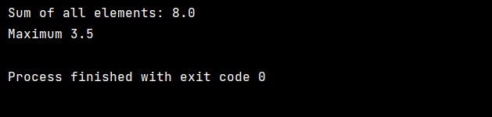

TASK 5

import java.io.File**;**import java.io.IOException**;**import java.nio.file.attribute.PosixFilePermission**;**import java.util.HashSet**;**import java.util.Scanner**;**import java.util.Set**;**//osmn  
public class Main {  
 public static void main(String[] args) {  
 System.*out*.println("Enter your designation")**;** Scanner get = new Scanner(System.*in*)**;** String designation**;** File f2 = new File("Confidential.txt")**;** try {  
 if (f2.createNewFile()) System.*out*.println("Created")**;** }catch (IOException e){  
 e.printStackTrace()**;** }  
 designation=get.next()**;** if (designation.equals("Faculty")){  
 Set<PosixFilePermission> permissions = new HashSet<>()**;** permissions.add(PosixFilePermission.*OWNER_WRITE*)**;** permissions.add(PosixFilePermission.*OWNER_READ*)**;** permissions.add(PosixFilePermission.*OWNER_EXECUTE*)**;** System.*out*.println("RWX")**;** }  
 else if (designation.equals("Student")){  
 Set<PosixFilePermission> permissions = new HashSet<>()**;** permissions.add(PosixFilePermission.*OWNER_READ*)**;** System.*out*.println("read Only ")**;** }  
 else System.*out*.println("wrong input")**;** }  
}

